
12 ATAR Physics

Quantum Physics & Light
Evaluation & Analysis 2016

Name: Mark:

Read the following passage and answer all the questions.

The photoelectric effect is the ejection of electrons from the polished surface of a metal caused by light particles (photons) hitting the surface. The emitted electrons are referred to as photoelectrons. The experimental arrangement used to demonstrate the photoelectric effect can be seen in Figure 1 below.

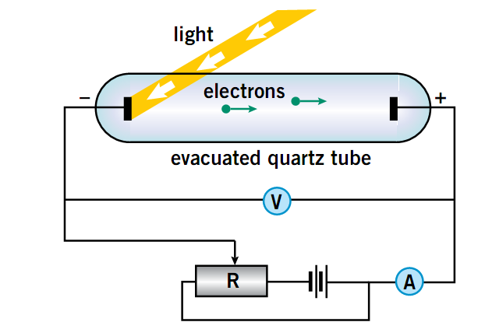
Figure 1: Photoelectric effect – light shining on the cathode
produces electrons that are accelerated towards the anode.

Light shines onto the metal surface, the cathode. If the light causes photoelectrons to be emitted, they travel through the vacuum and can be detected at the anode. A photoelectric current will be measured by the ammeter. A variable voltage supply can be used to make the cathode negative and therefore the anode positive. The resulting electric field accelerates the photoelectrons toward the anode and a maximum possible current is measured. A reserve potential can be applied so that the cathode becomes positive and the anode negative. This arrangement can be used to investigate the kinetic energy of the photoelectrons.

The photoelectric effect for any particular metal is only observed when light above a given frequency (the threshold frequency) is illuminating the metal. If the frequency of the incident light is less than the threshold frequency, no photoelectrons are emitted. If the frequency is greater than the threshold frequency of the metal, the absorption of light can free some photoelectrons. The minimum energy required to release a photoelectron from the metal is called the work function and is a particular property of a material. The photoelectric effect is an example of experimental evidence that supports the particle, or photon, model of light.

Two equations are used in photoelectric effect calculations:

E_{K(max)} = qV_{(stop)}

E_{K(max)} = hf - φ

Where:

q | = | electron charge
V_{(stop)} | = | the potential difference at which the ammeter reading just drops to zero
E_{K(max)} | = | the kinetic energy of the most energetic photoelectrons
h | = | Planck’s constant
f | = | the frequency of the incident light
φ | = | the work function of the target metal

These equations can be combined to give:

hf = qV_{(stop)} + φ

The work functions for a number of metals are recorded in the table below.

 | Metal | Work function (eV)
 | Copper | 4.70
 | Gold | 5.10
 | Potassium | 2.30
 | Platinum | 6.35

Table 1.

In a photoelectric experiment, the following values were measured.

 | Frequency of incident light (x10¹⁵ Hz) | V_{(stop)} (V) | E_{K(max)} (J)
 | 1.20 | -0.40
 | 1.30 | -0.70
 | 1.50 | -1.60
 | 1.67 | -2.20
 | 2.00 | -3.05
 | 2.14 | -4.20
 | 2.50 | -5.65

Table 2.

1. The text in paragraph 3 mentions the photon model of light. What other model of light have you studied? Describe one phenomenon or experiment that supports this other model. [5 marks]

2. Make the necessary calculations and enter the results into table 2 on the previous page. Use the table to draw a graph (on next page) of E_{K(max)} in Joules against frequency in Hertz. Draw a line of best fit. [4 marks]

3. Use the graph to determine the intercept on the frequency axis of the graph and use it to determine the work function of the metal. [4 marks]

Answer:

4. Using table 1, the work function values and the answer to question 3, determine the metal used to collect the data you have just analysed. [4 marks]

Answer:


5. Calculate the wavelength of light that corresponds to the threshold frequency for the metal in question 4 and state to which part of the electromagnetic spectrum it belongs. [3 marks]

Answer:

6. The variable DC source is removed and replaced by a conducting wire. Will the ammeter still be able to detect a current when the light shines on the cathode? Justify your answer. [4 marks]

7. From the analysis you performed in the laboratory, identify the line emission spectra shown below. [6 marks]

Sample | Line emission spectra
(a) |  | 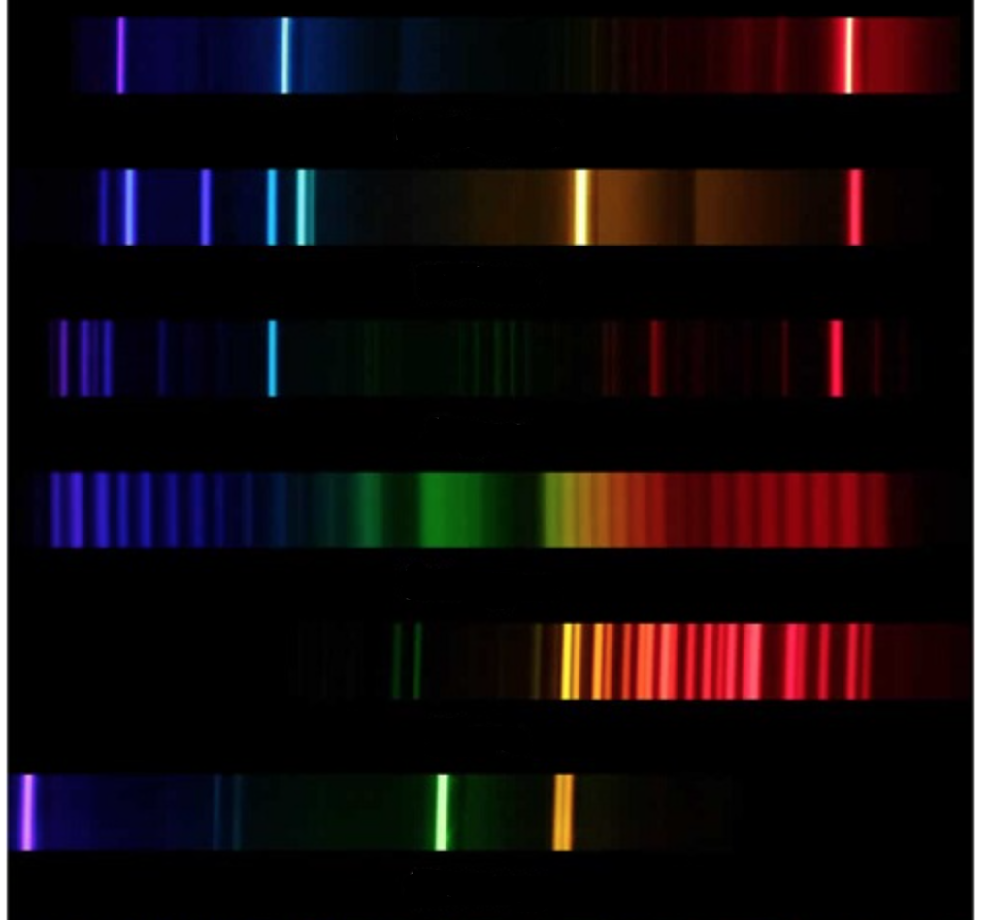
(b)
(c)
(d)
(e)
(f)

(i) Sample (a) is element
(ii) Sample (b) is element
(iii) Sample (c) is element
(iv) Sample (d) is element
(v) Sample (e) is element
(vi) Sample (f) is element

8. Refer to the short YouTube video you watched while conducting your research. Explain what is being seen for each situation shown here.

a) | 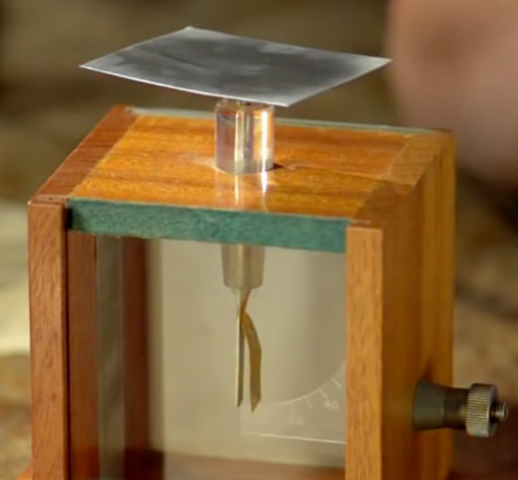
[2 marks]

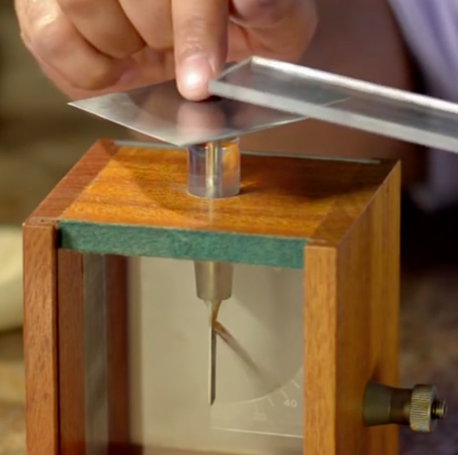 | b)
[2 marks]

c) | 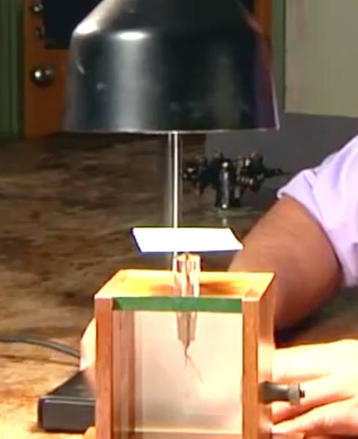
[2 marks]

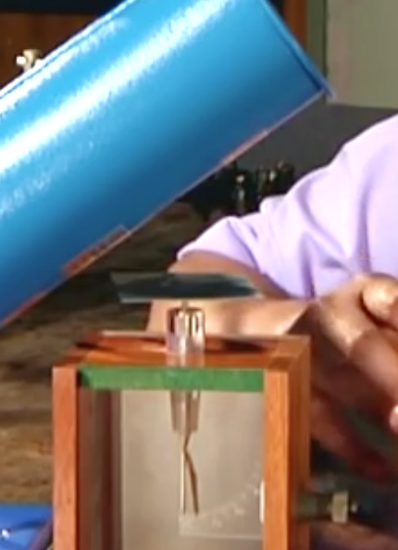 | d)
[2 marks]

